Experiment 7

Sequence diagram for login into system:

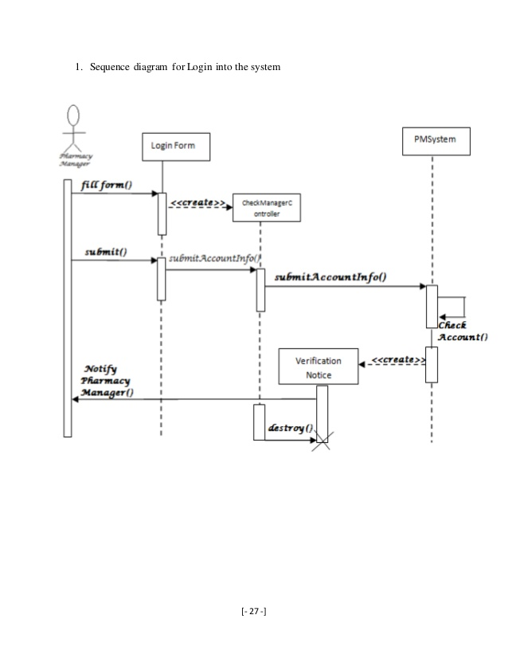

Collaboration Diagram for adding a user:

